Post Covid-19 measures taken by CIECA members
CIECA members’ recovery plans

TEMPLATE

CIECA members have already started to plan and implement measures to gradually get back to work after the Covid-19 outbreak.

This document compiles information on a series of issues that need to be considered when planning the resuming of all testing activities. Although the list of issues provided (1) should not be considered exhaustive, and (2) will vary from jurisdiction to jurisdiction, there will be many common elements to bear in mind, and CIECA is convinced that it will be extremely beneficial to think collectively about these issues among members. We invite all CIECA members to consult this document and we hope that it will contain useful information for your organizations.

The document includes information on the following issues:

- Current situation due to Covid-19 in your country.
- Challenges for resumption of services (e.g. high demand for tests / backlog, health requirements in order to control possible reinfections, possible risks regarding testing of certain categories – A, B, BE and W, suitability and adaptation of premises, housekeeping and cleaning requirements – handling of vehicles for testing, compliance with periodic training requirement, how to meet additional costs brought by the Covid-19 outbreak.
- Are there any other specific measures that have been considered by your organization in relation to the theoretical tests?
- Are there any other practical measures that have been considered by your organization in relation to the practical tests?

We also encourage all members to send the information related to their own measures so it can be included in the list of resources developed by CIECA on this matter. Please take into account that this document should be considered as a DRAFT, and that we are working to present the information in a more cohesive way. If you intend to send information about your country’s measures, a template to compile the information will be ready to be used by all members by 30 April 2020. The template will be distributed through our Newsletter, and also available at the CIECA website.

If you have any questions or doubts about how the information should be provided, you might like to refer to the information already published in the report when giving the information related to your own organization.

We would like to thank Lars Rößger from TÜV | DEKRA arge tp 21 GbR, for the development of this template, and for letting us use it in the report.

COUNTRY – CIECA MEMBER

1. Current Situation
- Lorem ipsum dolor sit amet, consectetur adipiscing elit. Nullam imperdiet diam nec purus sagittis laoreet. Fusce bibendum mauris eu diam mollis, luctus finibus massa vulputate. Pellentesque sit amet tortor imperdiet, accumsan magna id, semper nulla.
- Etiam pulvinar sapien odio, at faucibus metus vehicula et. Nulla tincidunt in sapien sit amet euismod. Maecenas faucibus convallis elit, quis tristique est cursus ut. Fusce quis elit orci. Nullam condimentum auctor iaculis.

2. Specific measures taken for theory test
- Lorem ipsum dolor sit amet, consectetur adipiscing elit. Nullam imperdiet diam nec purus sagittis laoreet. Fusce bibendum mauris eu diam mollis, luctus finibus massa vulputate. Pellentesque sit amet tortor imperdiet, accumsan magna id, semper nulla.
- Etiam pulvinar sapien odio, at faucibus metus vehicula et. Nulla tincidunt in sapien sit amet euismod. Maecenas faucibus convallis elit, quis tristique est cursus ut. Fusce quis elit orci. Nullam condimentum auctor iaculis.

2. Specific measures taken for practical test
- Lorem ipsum dolor sit amet, consectetur adipiscing elit. Nullam imperdiet diam nec purus sagittis laoreet. Fusce bibendum mauris eu diam mollis, luctus finibus massa vulputate. Pellentesque sit amet tortor imperdiet, accumsan magna id, semper nulla.
- Etiam pulvinar sapien odio, at faucibus metus vehicula et. Nulla tincidunt in sapien sit amet euismod. Maecenas faucibus convallis elit, quis tristique est cursus ut. Fusce quis elit orci. Nullam condimentum auctor iaculis.

2. Fields of action and categories of measures

Potential needed measures in connection with COVID-19 can be roughly subdivided into three categories:
- Distance measures: These include measures that make the person-to-person transmission unlikely simply by ensuring a distance between people (e.g. distances between applicants when performing the theory test, specific work schedules to avoid cross-contamination among employees).
- Hygienic measures: These include measures that counteract a specific infection or spread of viruses through physical or disinfectant prevention (e.g. disinfection of work equipment, calls for hygiene when coughing and sneezing, ventilation of rooms, wearing mouth protection, provision of hand disinfection points etc.).
- Awareness and information measures: These include measures to raise awareness and understanding among applicants and employees and to impart acceptance and the necessary knowledge about changed procedures (e.g. notices, displays, brochures, social media, etc.).
Within the measure categories, it can be considered for each field of action which concrete implementations are conceivable or are already being planned. Furthermore, it might be useful to differentiate for individual fields of action according to process stages, i.e. preparation (in advances to the exam), implementation (taking the exam) and follow-up (after the exam has been completed).
These considerations can be illustrated as depicted in Figure 1 whereby the aim is to fill the cells in this structure with concrete measures.
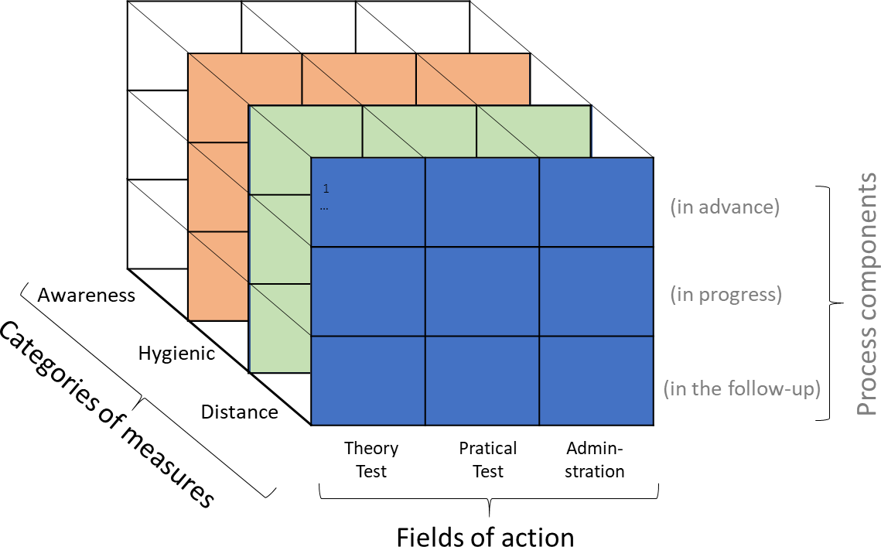

Figure 1: Structure of measure package(s)

3. Proposals of measures within the structure

3.1. Theory Test

 | In advance | during execution | in the follow-up
Distance
Hygienic
Awareness

3.2. Practical Test

 | In advance | during execution | in the follow-up
Distance
Hygienic
Awareness |  |  | •

3.3. Administration

 | In advance | during execution | in the follow-up
Distance
Hygienic
Awareness

